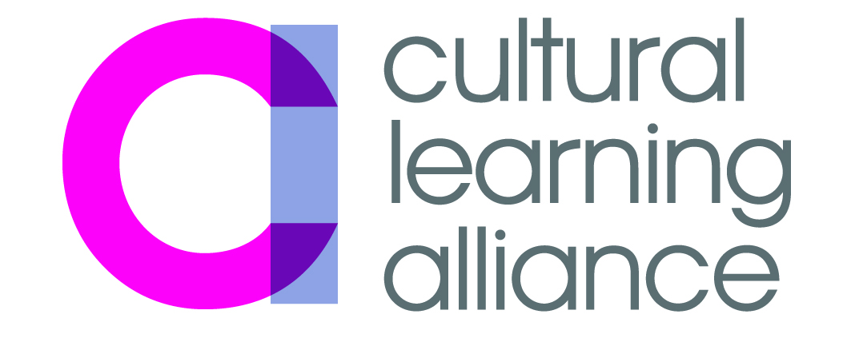

Cultural Learning Alliance
Briefing: History of Art A-level Closure
01/11/16

Over the last few weeks we have seen a great deal of press about the decision by Examination Board AQA to close the History of Art A-level, including articles in The Times, The Telegraph, and the Independent. This briefing aims to give you some the facts and figures behind it all.

What is the current picture?
History of Art A Level is only offered by one exam-board: AQA.
The numbers of young people taking the qualification have always been comparatively very small:
In 2016 839 students took the full A Level and 721 took the AS Level
In comparison 43,242 students took Art and Design A Levels in 2016, and 41,545 took AS Level; 54,731 took History A Level and 61,304 took History AS Level
The full numbers can be seen at the bottom of this briefing.
A 2014 Guardian article suggests that the breakdown of private schools vs independent schools that offer the A Level is as follows:
‘A Level History of Art is offered at only 17 state secondary schools out of more than 3,000, plus a further 15 sixth-form colleges. By contrast, over 90 fee-paying schools offer the subject.’
In the Huffington Post [15 October 2016] Munira Mirza puts it at 16 state schools and 90 private schools.
University History of Art courses do not require History of Art as an A Level for entry.

Why is AQA axing the subject?
AQA is claiming that it is axing the subject for commercial reasons; it cannot make the subject profitable due to the small numbers, and because the specialist nature of the subject makes it hard to find experienced examiners. You can read their full statement here.
The decision is coming from the exam board and not from the government or Ofqual. In contrast, Creative Writing as an A Level is being axed because the DfE says it ‘has not been possible to draft subject content in accordance with its guidance, and Ofqual's principles for reformed AS and A Levels’.
A large number of the articles on the subject have blamed Michael Gove’s reforms for the removal of the subject. He himself has taken to Twitter to claim this is not the case (as reported in the TES)
The excellent National Society of Education in Art and Design has put out this statement, and the Association of Art Historians has issued this press release in which it states:
‘The decision to discontinue History of Art at Key Stage 5 will mark a significant loss to young people’s access to - and understanding of - a range of different cultures, artefacts and ideas. Signposting educational opportunities, such as an A level in art history to students who may never have considered this an opportunity, has also formed a significant part of our campaign work’

What is the wider picture?
A Level Art History has not been the direct victim of government policy intervention, but it is fair to say that the policy and practical climate is not one that encourages wider arts education to flourish. In fact, we are currently at a moment of crisis for the arts in schools.
21% fewer arts GCSEs were taken in 2016 compared to 2010, while the number of children in the cohort only declined by 6%. There is also evidence that the decline in studying arts subjects post-14 is gathering speed, with an 8% fall in the numbers entered between 2015 and 2016. Between 2010 and 2015 the number of hours the arts were taught in secondary schools, and the number of arts teachers, both fell by 15%.
The reasons for this decline are complex. The Introduction of the English Baccalaureate at GCSE and as a headline school accountability measure has sent a clear message to schools, teachers, parents and students that the arts don’t count and are not valued by government. Read our EBacc briefing for full details.
Student teachers in arts disciplines tend not to be eligible for bursaries to train (with the exception of Design and Technology and Music – and these are very much smaller than the bursaries for Physics, Maths and Chemistry). Although there are places offered in arts teacher training, many of these are left unfilled.
There has been a recent change to policy whereby AS Levels and A Levels have been uncoupled: students used to be able to do an AS year as a taster and then go on to a year of further study to complete the full A-level. Now this is no longer the case, it means that students are much more risk-averse in their choices.
The Department for Education is clear that it ’makes no apology’ for weighting the system in this way.
In a speech in June 2015 Minister for Schools Nick Gibb said:
“It has also been suggested that our emphasis on academic subjects in the national curriculum, and especially the introduction of the EBacc, ‘crowds out’ the study of other important subjects, particularly the arts.
We should acknowledge that the curriculum always involves trade-offs: more time on one subject means less time on others. Over the years, I’ve been asked to add scores of subjects – from intellectual property, to Esperanto, to den building – to the national curriculum. Many of these are important and interesting.
The question, though, is always whether they are sufficiently important to justify reducing the time available for the existing subjects in the curriculum, and I make no apology for protecting space for the English Baccalaureate subjects wherever possible.”
Art History A Level is the victim of market forces, but we have to ask whether educational choices should be determined by the market. All young people need to be given the widest possible opportunity to engage with a broad and balanced education, and disciplines like Art History enable them to be rigorous, critical and curious, using a frame that they may not have encountered before and enabling them to access the cultural capital that art history offers. As long as the breadth of study at A-level is determined by commercial factors, we either have to invest in raising awareness and demand for the arts, and/or we have to call for subjects with smaller uptake to be subsidised.

AQA figures only: 2010 to 2016
Art History A Level
2010: 908
2011: 897
2012: 976
2013: 760
2014: 824
2015: 769
2016: 839
Art History AS Level
2010: 913
2011: 1055
2012: 919
2013: 866
2014: 821
2015: 902
2016: 721

